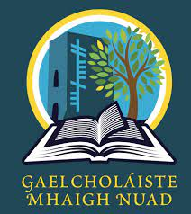
Tionscnamh frith-bhulaíochta
We created a 4-week module on anti-bullying for our wellbeing class. Students first discussed the different types of bullying and the consequences of bullying. The students reviewed the school policy on bullying and what to do if bullying occurs. Students then brainstormed ideas and they decided to create an animated video to show other students what to do if they are being bullied. Students worked in groups to create animated videos with Animaker.com. Students then showcased their videos to the class and discussed the content and gave feedback on the videos.
The links to videos are attached below.

Folláine 1:
https://app.animaker.com/animo/cQNIU5jgPO5iLTcm/
https://app.animaker.com/animo/rem5yGA7jdfThCLp/

Folláine 2:
https://app.animaker.com/animo/0nJEA62wWwFJCy9g/?shareid=view|0nJEA62wWwFJCy9g
https://app.animaker.com/video/ND2TB4L6CDFEDX3H
https://app.animaker.com/animo/vT0dqPfuQTvXnSs7/

