Baltinglass
Welcomes

Last year the Student Council in Scoil Chonglais Baltinglass ran a Non-Uniform Day in aid of Baltinglass Welcomes. This organisation aimed to raise €10,000 to allow one Syrian family to move permanently into the local area. This was widely supported and awareness of diversity and inclusion was promoted for Syrian Refugees in our school and community. Just over €951 was raised by the school community in conjunction with the Parents Council. This sent a strong message of inclusion and support for diversity in our school and local community.

Details Below:

Urgent Appeal for a Syrian family living in a refugee camp

The Baltinglass Welcomes committee is partnering with the Irish Red Cross to support the resettlement of a Syrian a refugee family in Baltinglass as a part of the Department of Justice and Equality Community Sponsorship Ireland program.

The crisis in Syria has resulted in over 6 million refugees who have fled the devastation of civil war. Some of those are currently living in refugee camps in neighbouring countries. In 2015, the Irish government pledged to welcome up to 4,000 Syrian refugees to Ireland and more than 2,000 have already resettled in our country.

Our objective is to make all of the arrangements for resettlement of a family in need currently living in a refugee camp in Lebanon. We will sponsor a family that will live in Baltinglass and become members of Irish society. In order to do this, we need support from many individuals and groups across our community.

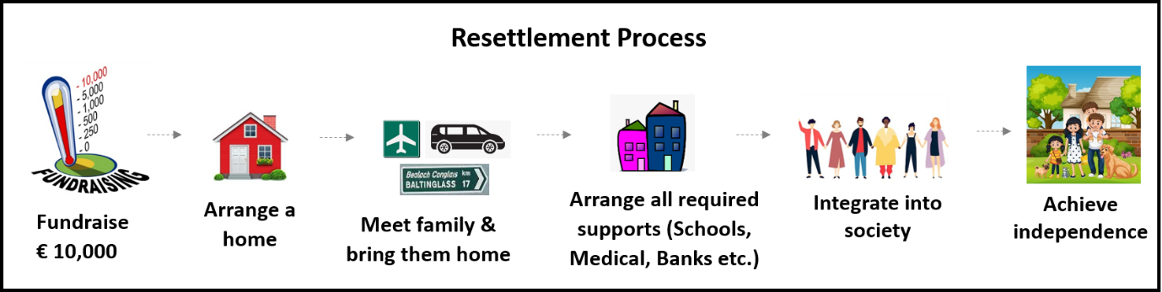

A photo from the local newspaper is attached below.
