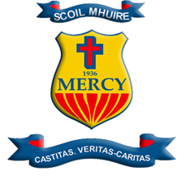
SCOIL MHUIRE TRIM
Patrick Street Trim Co Meath Ireland

The Stand-Up Committee is an extracurricular activity in our school that raises awareness of LGBTQ+ issues.

- We encourage co-operation between students in different years. Our committee has members from first year right through to sixth year, all of whom work together with a common goal.
- We create a welcoming, inclusive and safe environment for all students, those who identify as part of the LGBTQ+ community, those that are an ally and those who simply want to learn.
- We are currently planning to run a Stand-Up week in November to continue to raise awareness and show students that schools can be a safe space to be their authentic self.
- We are actively preventing homophobic bullying by consistently linking in with the wellbeing and antibullying committee. In doing this, we show that our school has a no tolerance policy for such behaviour and that it welcomes and celebrates the diversity of the student body.
- We have organised for the organisation ShoutOut to give talks to our students, again to raise awareness as well as organising various guest speakers that identify as part of the LGBTQ+ community.
- We raise awareness of the correct LGBTQ+ terminology by creating bunting and flags that will be hung in various parts of the school. We will also have a word of the day that will be read out over the intercom at form time.
- We encourage student involvement and cooperation across all year groups. We will organise a whole school rainbow jumper day.
- Our school has a number of student outdoor benches, one of which we will paint in the LGBTQ+ colours.
- We will organise a bake sale to raise money for various LGBTQ+ charities

