**WHAT WE DID:**

**Anti-Bullying Week**

**Bullying Workshop-Classroom Guidance Workbook.**

**Slogan Competition**

**Cyber safety awareness**

I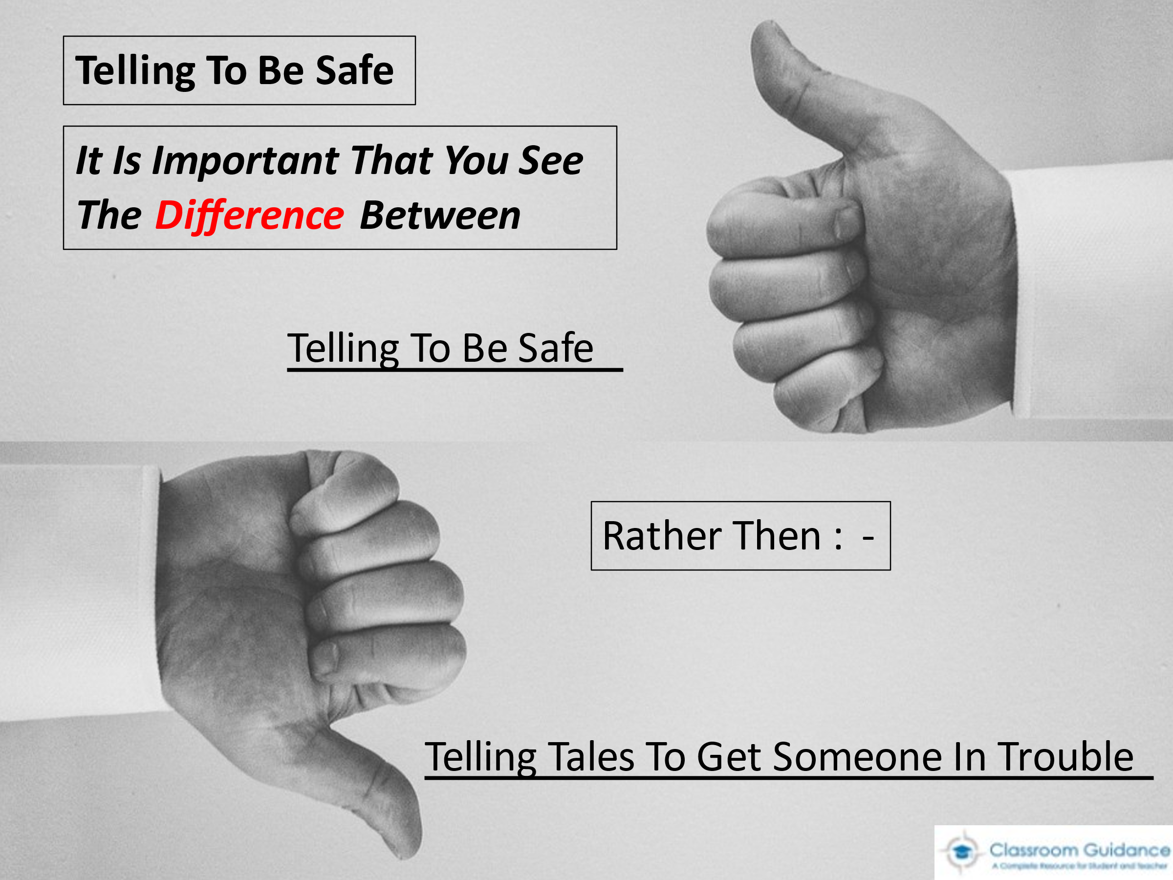MAGE 2

IM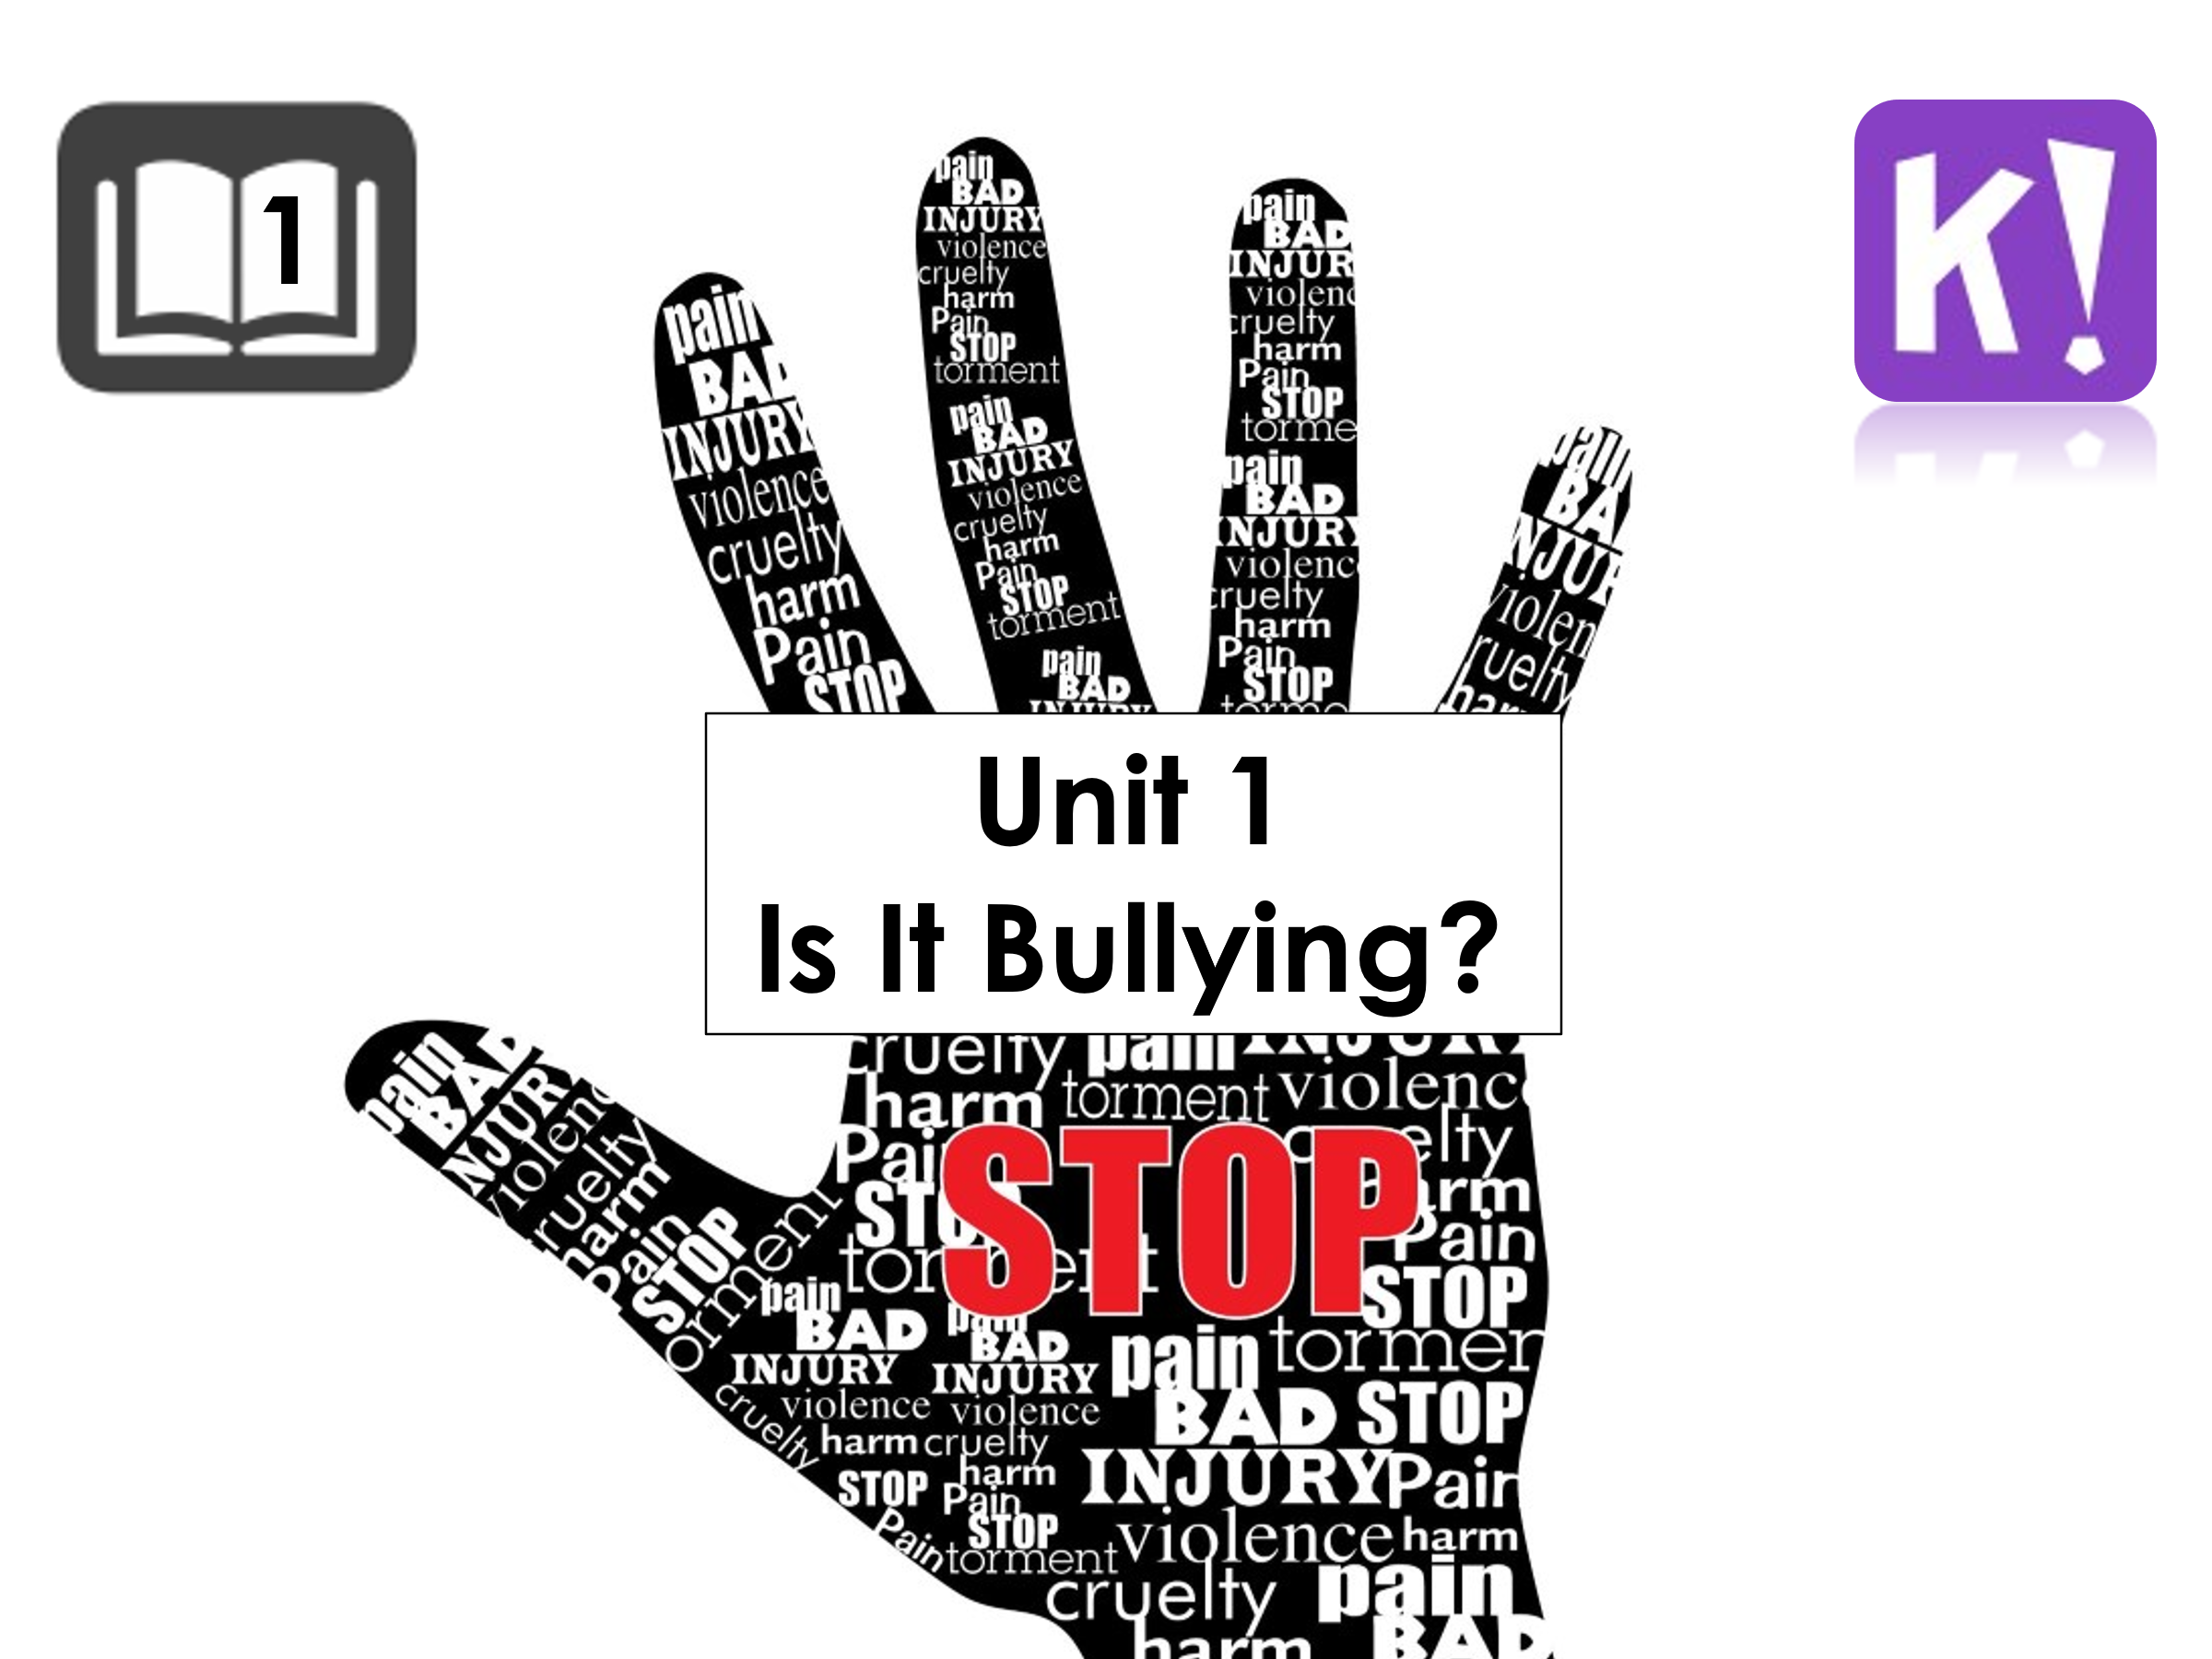AGE 1

**HOW WE DID IT:**

**The committee organised a classroom-based activity for all the SPHE classes and a slogan competition was created for a chosen class Rhyme to remember how to prevent bullying. An anti-bullying week was run with various activities and advice presented to new 1st years from our current 6th years.**

**ADDITIONAL COMMENTS:**

**Cyber safety was enforced as due to lockdown, students have become very dependent as an extracurricular activity due to other activities been halted! This will be revisited on cyber safety day, with our school ambassadors**

**COMPLUSORY THEME / OPTIONAL THEME**

**TITLE OF THEME: Bullying-Compulsory**

**SCHOOL NAME: Saint Patrick’s Cathedral Grammar School**