We want our school to be a Bully-free zone

We, 5th and 6th classes at Scoil Naomh Eirc, Kilmoyley, take bullying very seriously. We wanted to get through to all the other children that bullying is wrong, that it can cause people to feel bad and that we all have a responsibility to stamp out bullying.

We decided to take a pledge not to bully and we invited all other classes to participate also. The response was overwhelming. All other classes agreed to sign the pledge.

The pledge contains words like compassion, respect, kindness, courage commitment and responsibility. We explained what these words mean to all the children. We then read the pledge to them and made sure that understood it.

Our Pledge
I make a commitment to take a stand against bullying.
I will treat others with respect and kindness.
I will have the compassion to not be a bully and the courage to not be a bystander.
It is my responsibility to report bullying.

We wanted all the children to feel involved so we asked them to draw their handprint and to sign it. We provided everyone with coloured card. We then stuck all the handprints around the pledge. It makes a nice display and draws children (and adults) attention to the fact that our school is a bully-free zone
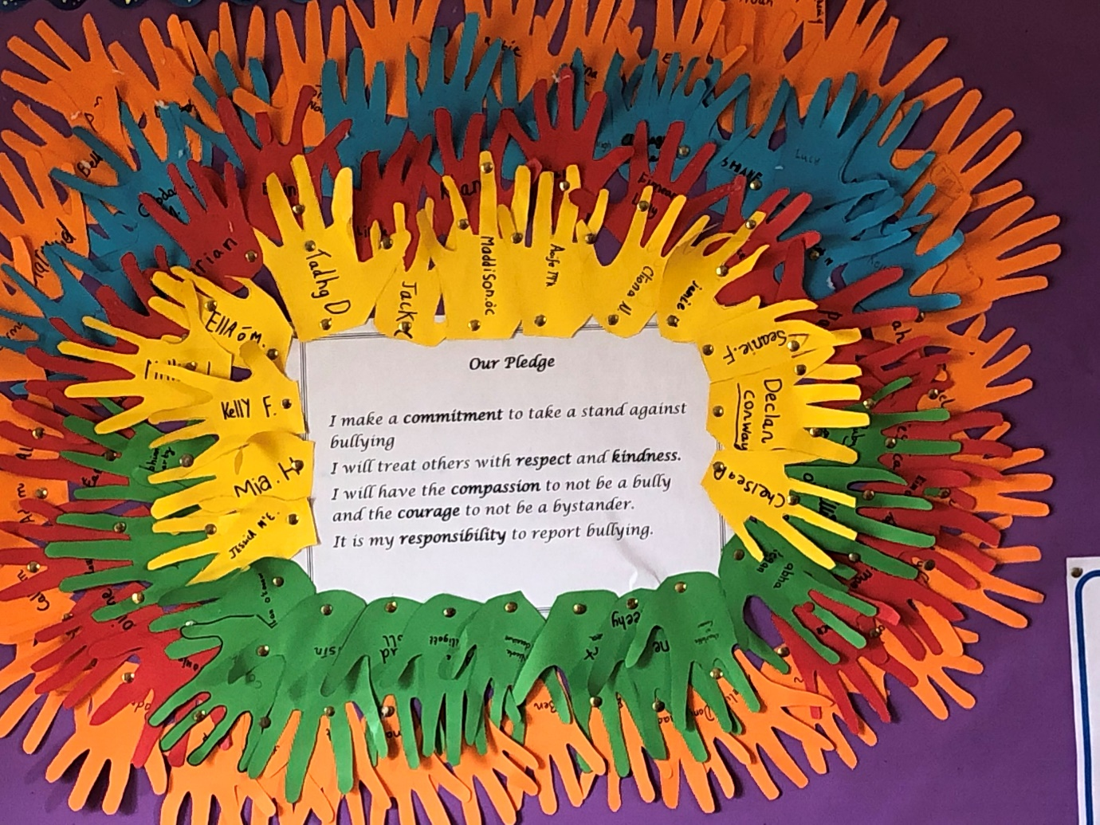

In our school we also use Restorative Practice to resolve issues. We have all noticed that our school is a happier place and everyone is calmer

