Initiative

Students in our anti bullying committee stuck up posters filled with positive quotes on all of the teachers doors, to remind the students how much they matter and to encourage them to always be kind and positive towards each other.

(Pictures below of the activity)

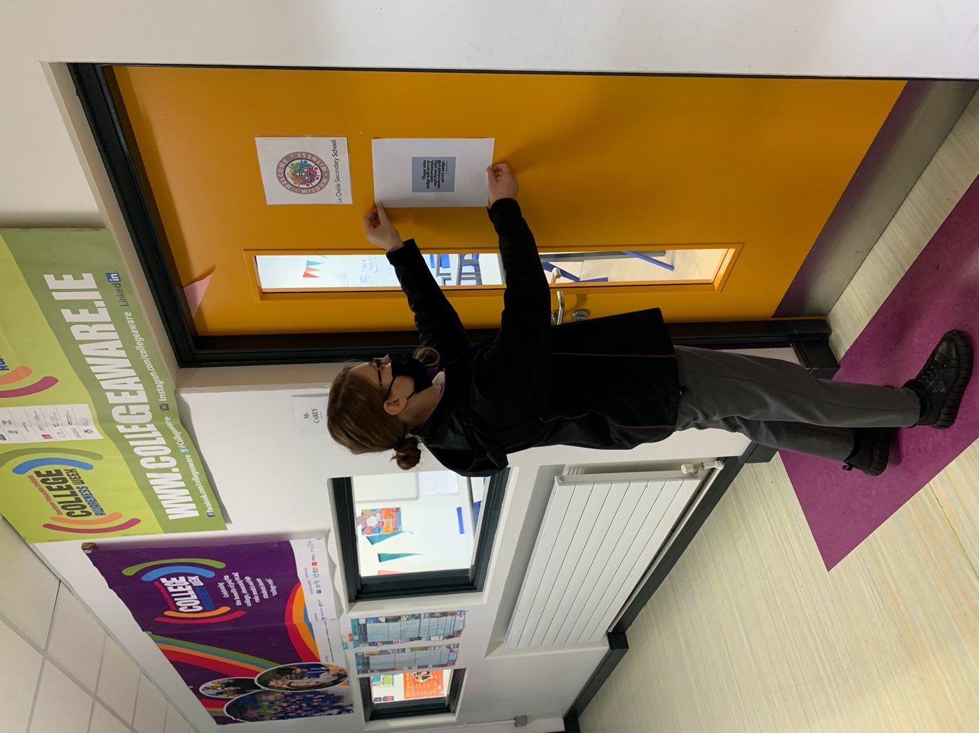
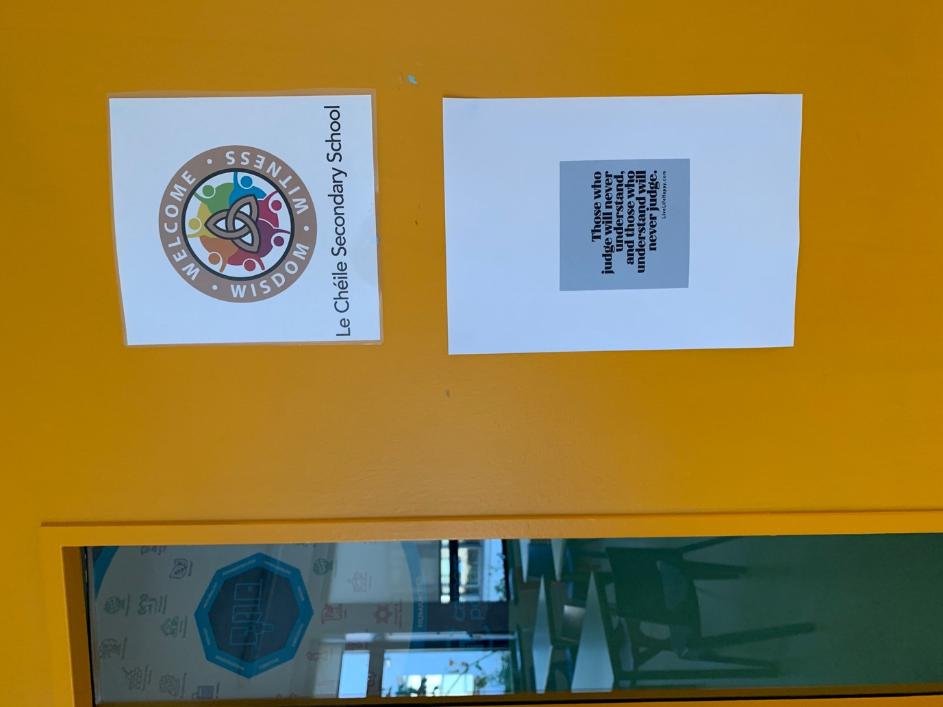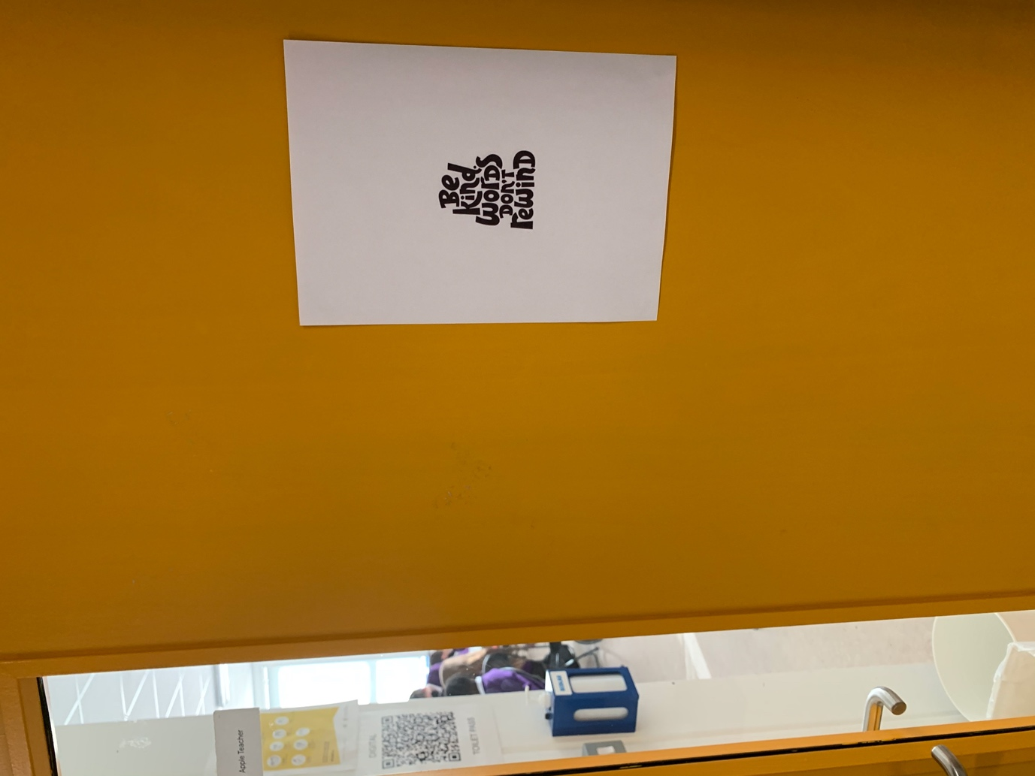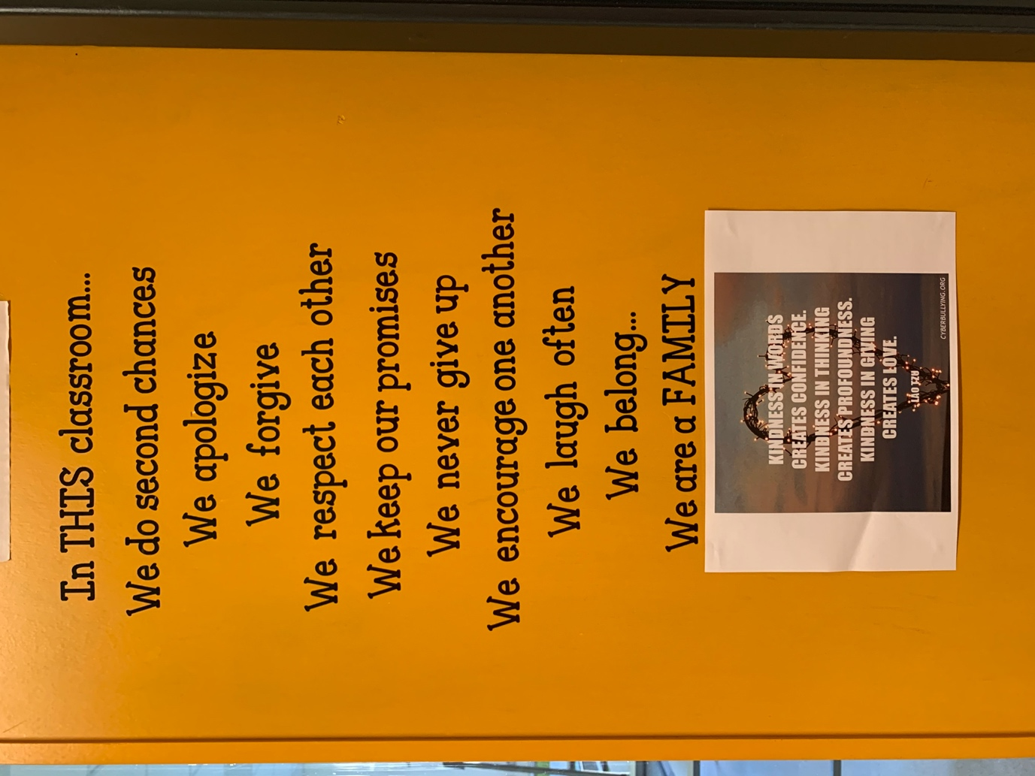

Students also met as a focus group with our guidance Counsellor to discuss how to tackle Bullying in our school. At the meeting, students shared their own personal experiences of Bullying and offered great practical solutions to help tackle issues of Bullying in the school community. This will also inform the anti bullying policy of our school.

One member of our anti bullying committee also made an intercom announcement to bring awareness to the ‘International day against violence and bullying at school’ and to remind students to always treat each other with respect. The catchphrase for the day for our school was ‘Sticks and Stones may break my bones, but words also hurt’ to remind students that cyber bullying and trolling comments also count as Bullying.

(Digital poster below made by a 5th year member of our anti bullying committee-which was hung around the school and shared on our school learning platform-Schoology)

